Data Structure and Algorithm (DSA)
BCSIT Second Semester
Set I

Short Question[2x10=20]
- Define Abstract Data Type (ADT).
- Define the principle of recursion.
- Write the algorithm steps for the PUSH operation.
- What is the purpose of the front and rear pointers in a queue?
- List basic operations performed on a linked list.
- Define the term "height" of a tree.
- Differentiate between internal and external sorting.
- Define Binary Search.
- Differentiate between DFS and BFS.
- Why Big 0 is mostly used?
Descriptive Question any five [5x10=50]
- Explain the various asymptotic notations used in algorithm analysis with diagram.
- Discuss the advantages and disadvantages of recursion over iteration. Write a program to implement Tower of Hanoi for n number of disks using c programming.
- Explain the queue data structure with its operations and terminology. Write a program to implement enqueue and dequeue in a circular queue.
- What are the advantages, disadvantages and applications of linked lists? Explain its types and operations.
- Define and differentiate between hashing with chaining and open addressing. Given a hash table of size 7 and a hash function H(k) = k % 7, resolve collisions using linear probing for the keys 50, 700, 76, 85, 92, 73, 101.
- Find the minimum spanning tree of a given graph by using Kruskal’s Algorithm.
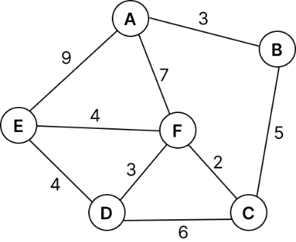

Analytical Question any Two[2x15=30]
- Explain infix, postfix, and prefix expressions with examples. Write an algorithm for converting an Infix expression to Postfix expression. Convert the following expression into Postfix showing content of the stack at each step. K + L – M * N * I + (O ^ P) * W / U – V * T + A
- What is sorting in DSA? Explain any 4 types of sorting algorithm with examples. Trace and sort the following data using the insertion sorting algorithm. 90, 56, 80, 10, 22, 21, 45, 9
- Explain all four rotations used in AVL trees with examples. Also, construct a AVL tree for the following sequence of keys: 50, 20, 60, 10, 8, 15, 32, 46, 11, 48 and perform the following:
- Show the AVL after all insertions
- Delete the node with value 20 and show the updated BST
- Write inorder, preorder, and postorder traversals of the final tree

